How to Log in to RingCentral Using SSO

Introduction
Single Sign-On (SSO) allows you to log in to RingCentral using your Union County Credentials, providing a secure and seamless experience. Follow the steps below to log in using SSO.

Step-by-Step Instructions
- Open the RingCentral application on your device.
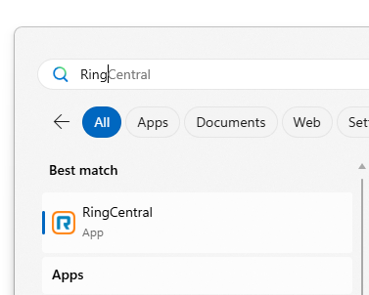

- Click on the 'Sign In' button on the main screen.
- Select the 'Single Sign-On (SSO)' option from the login choices.
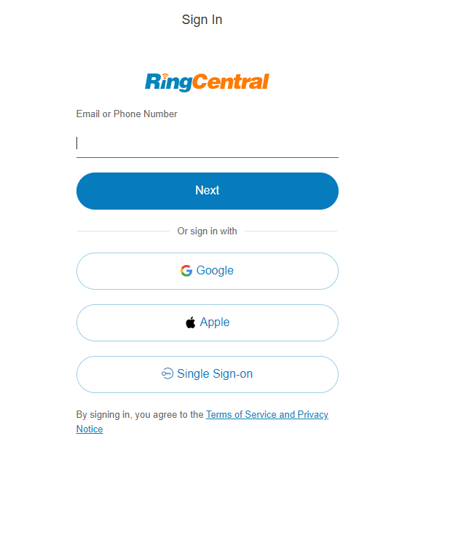
- Enter your Union County email address and click 'Submit'.
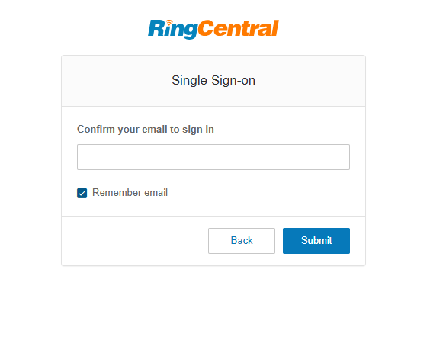

- You will be redirected to your organization's login page. Enter your credentials and authenticate.
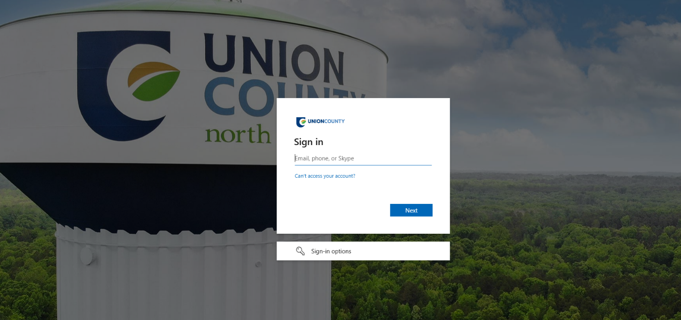

- Once authenticated, you will be logged into the RingCentral app successfully.

Conclusion
By following these steps, you can easily log in to RingCentral using SSO. Ensure you have your organizational credentials ready for a smoo

