Government Center:

Human Relations Training Room: 1st Floor
The Front of the room / Instructor Area
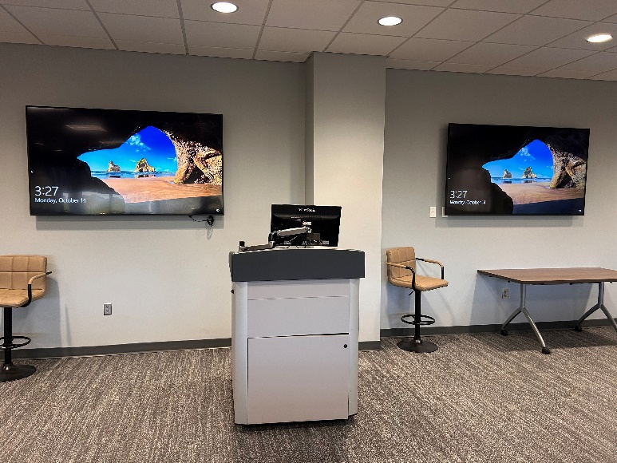

Power on the Interactive Touch Panel mounted on instructional wall column; press the power button
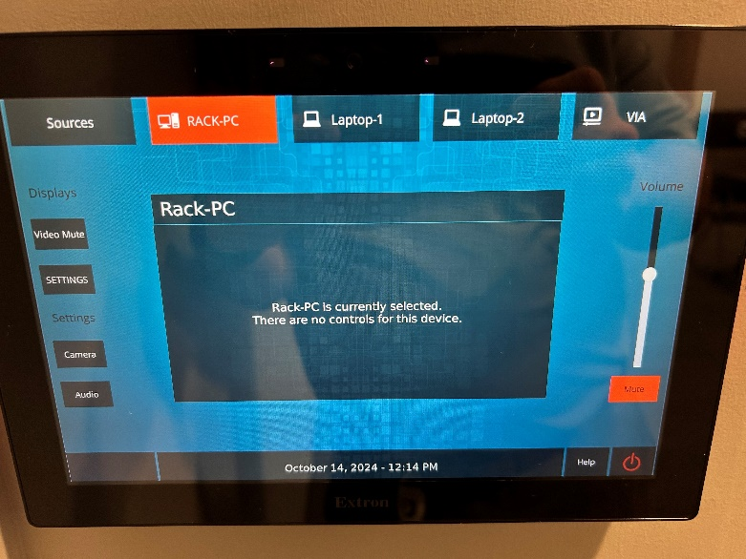
Power Button
There are 3 monitors on the sides

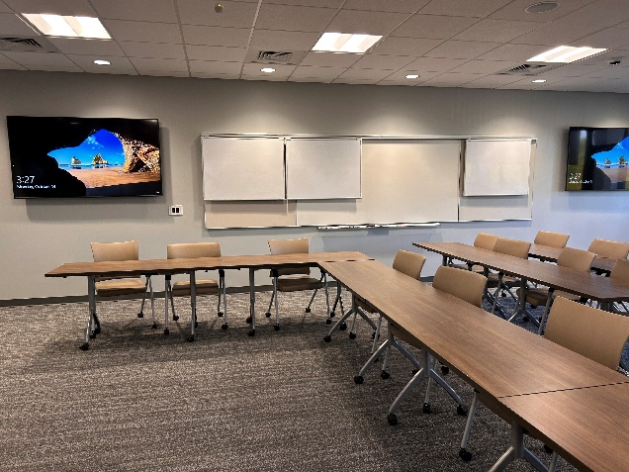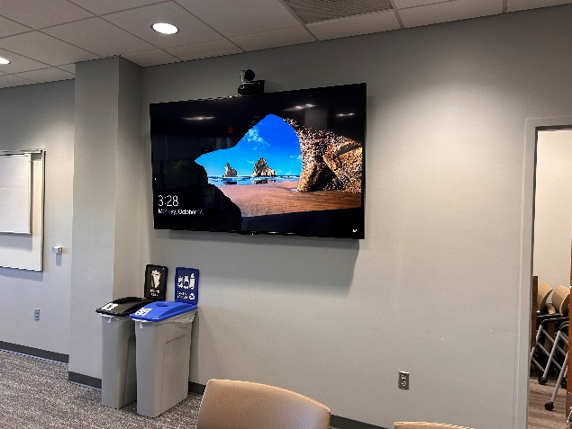

There are 2 wall input outlets. The 1st is behind the front right-side TV.

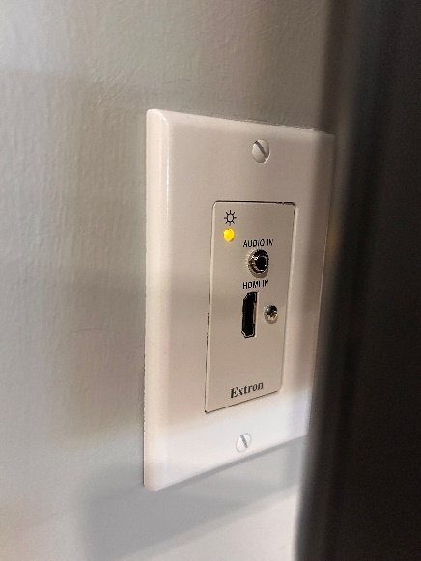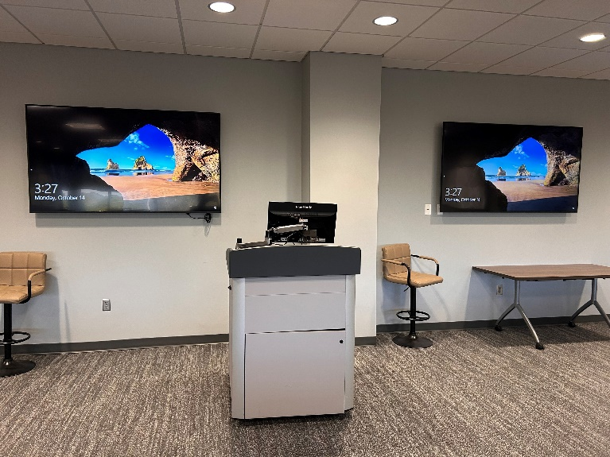

Laptop 1

The 2nd Input is on the Side with 2 TV panels
Laptop 2
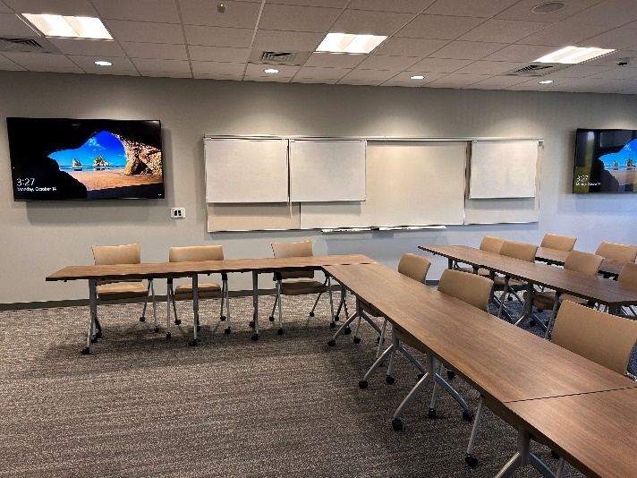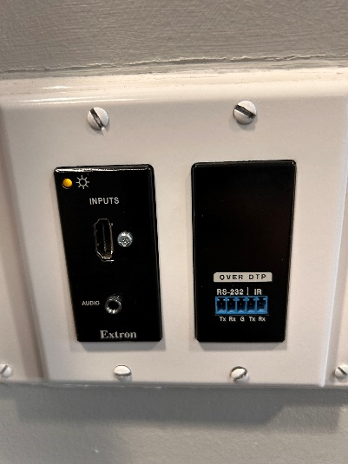

There is a camera in the training room for teams:
It’s connected to the Rack PC.

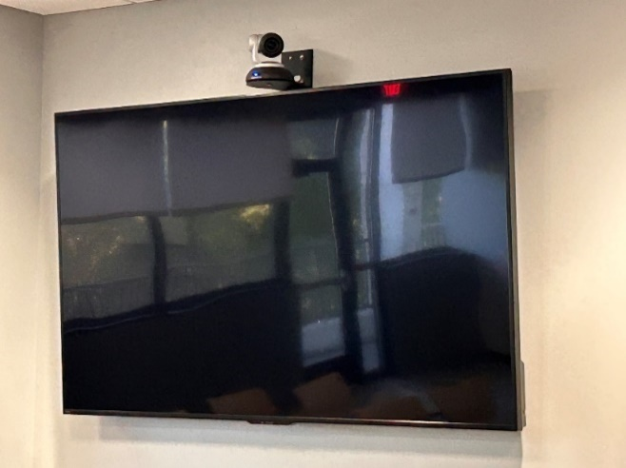
Camera going to the AV Rack

In the settings menu on the interactive touch screen, the displays can be turned on and off; individually if needed.
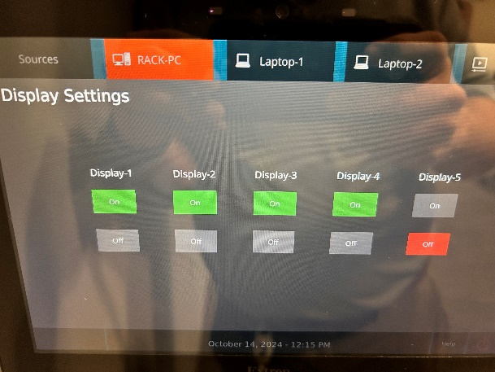

If your meeting requires a camera or the in-ceiling microphones, you will need to press the RACK-PC button on the interactive touch panel.

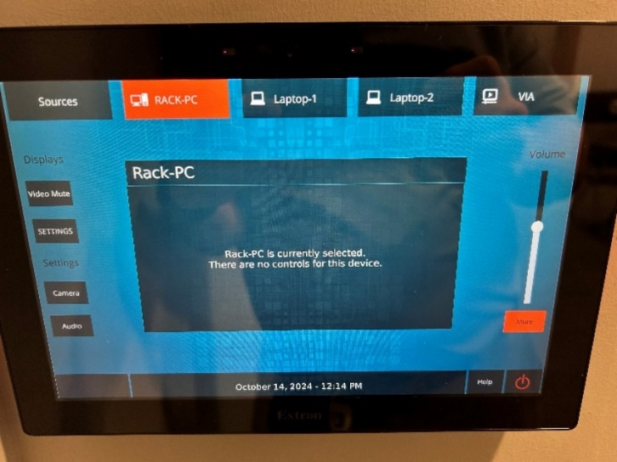

If you want to use the 2nd laptop wall ports input, you will need to connect the PC via HDMI. If they want to use the laptop camera & mic, a USB cable will need to be plugged into your laptop and the USB port with the input.

For wireless presentation select “Via” source.
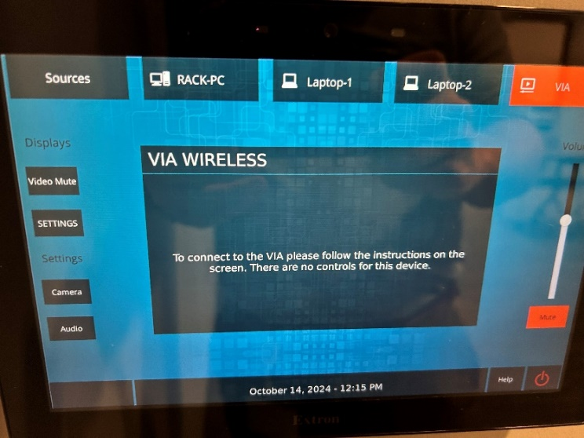

On your windows device press “Win+K”
This will bring up a pop-up menu to cast
Select the device “Device name”
If prompted enter the security code that will be displayed on the in-room screens
Select either mirror or extend your display.

