Government Center:

Planning Conference Room: Ground Floor
The Front of the room
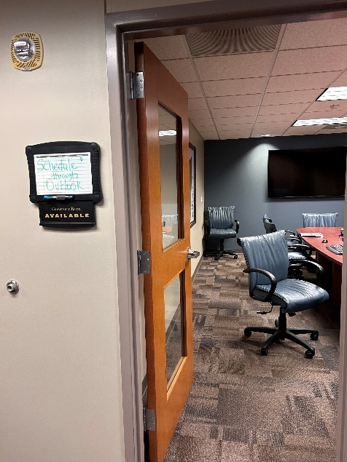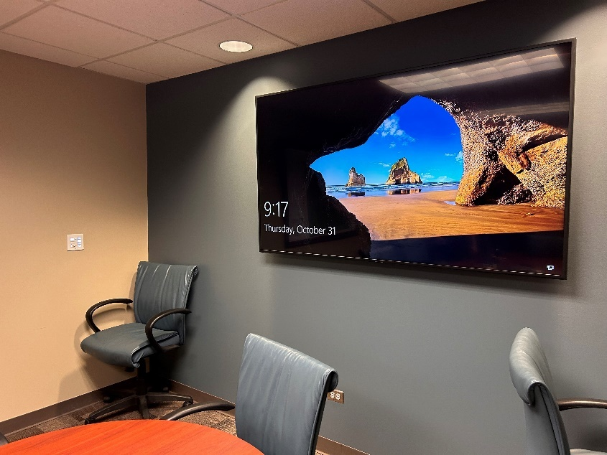

Power on the Control Wall Panel mounted at the front of the room; press the On button in the Display section.
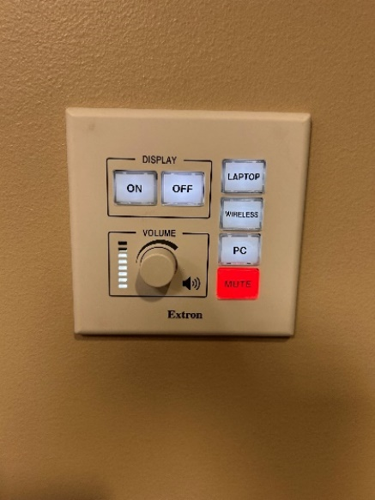
On Button

Your HDMI cable will go from the table port shown below to your laptop. Make sure to press the HDMI button on the Control Wall Panel.

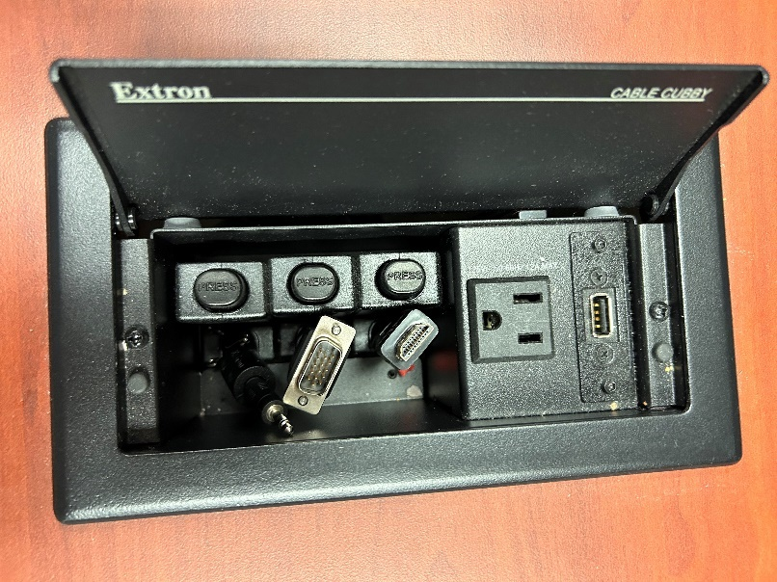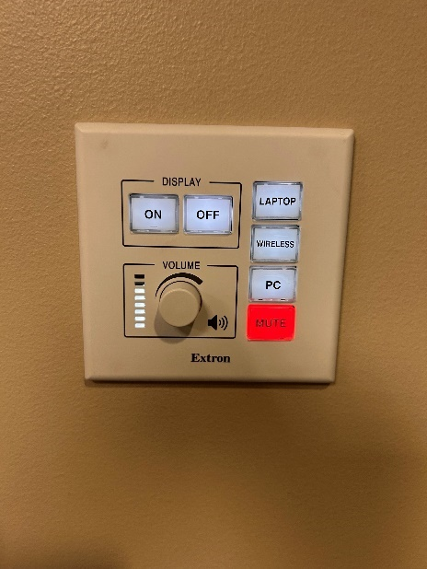
HDMI Button
HDMI Cable

There is a designated PC under the conference table. It can be used by pressing the PC button on the Control Wall Panel. Room audio volume is also with the Control
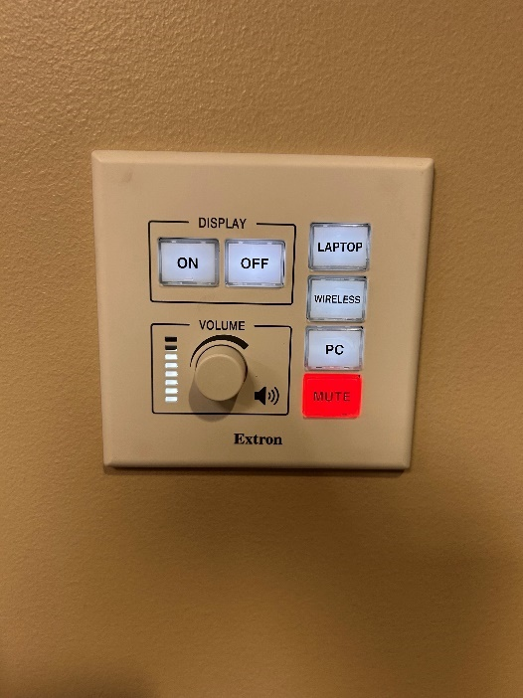
Volume Control & Mute Button

There is a Yeahlink Conference Phone on the table for use.
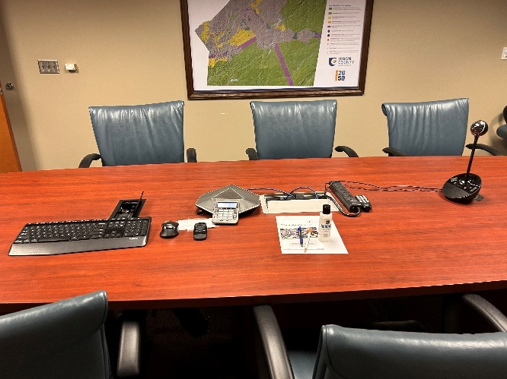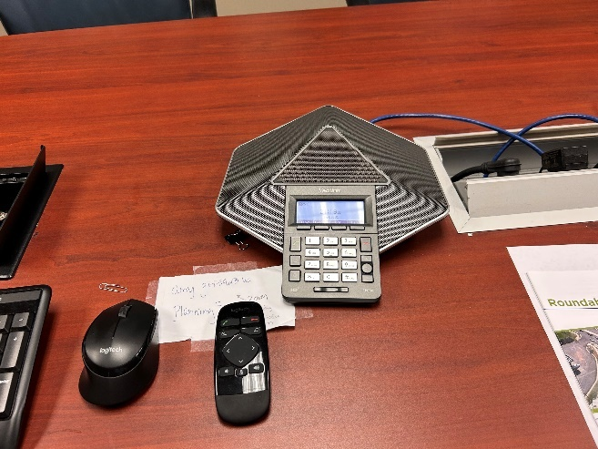

There is a Logitech – Camera and Microphone for use that is connected to the designated room PC for Teams or Zoom calls.
