Cane Creek Lodge:
The Front of the room has as Sharp 90” Commercial LCD TV
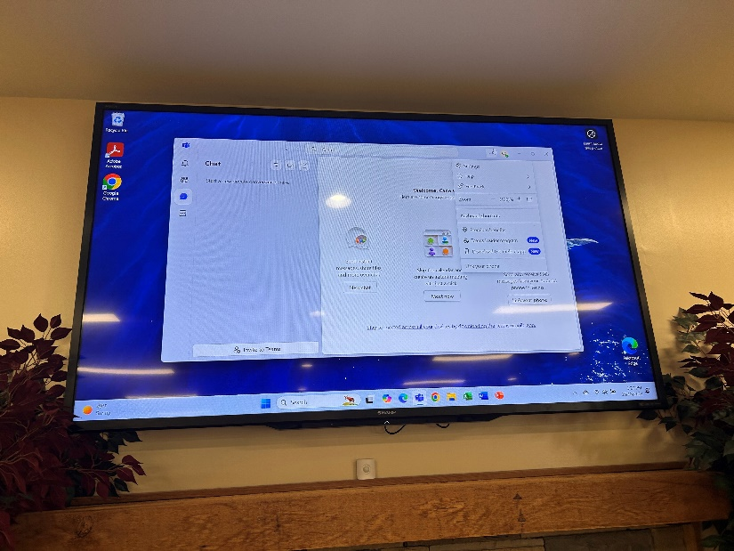

To connect to the presentation screen from the podium at the front left of room:
Power on the system by pressing the System on button.
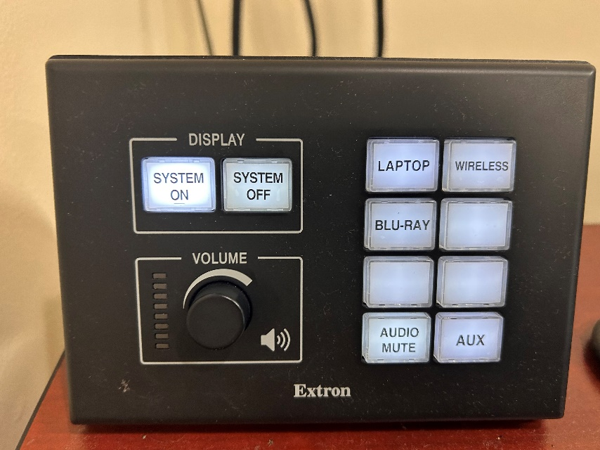
System On Button
The lodge has an assigned laptop that can be used.
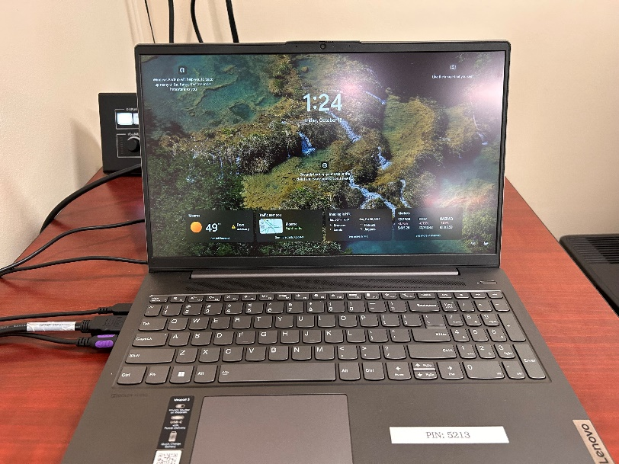
Pin Code 5213

It may ask for a pin code for use. The pin is 5213

If you would like to use a different laptop, take out the wired connections on the left side. The HDMI and 3.5mm The other cable is for power to the laptop.

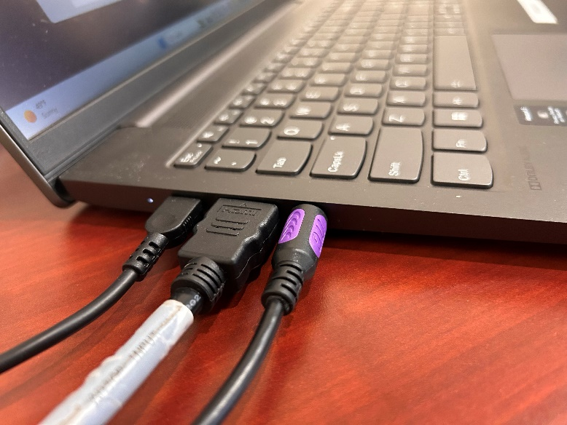
3.5mm Audio cable
Power
HDMI

The audio control is used by the knob below the “System On & System Off” buttons. If you would like to make sure there are no notification sounds to interrupt your presentation you will need to press the – Audio Mute button as seen below.

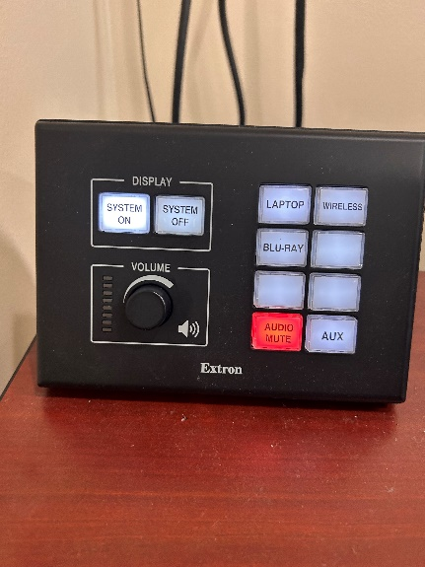
Audio Mute
Audio Volume Controls

There is a Blu-Ray player in the podium that can be used. You would need to open the podium door, turn on the Blu-Ray player, put in the disk and then press the Blu-Ray button

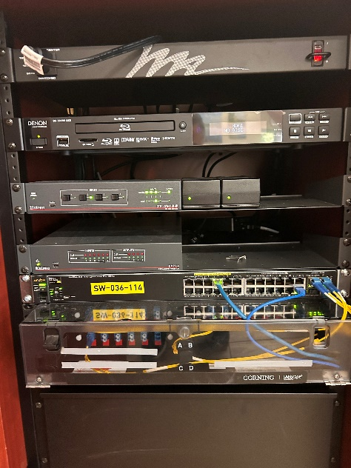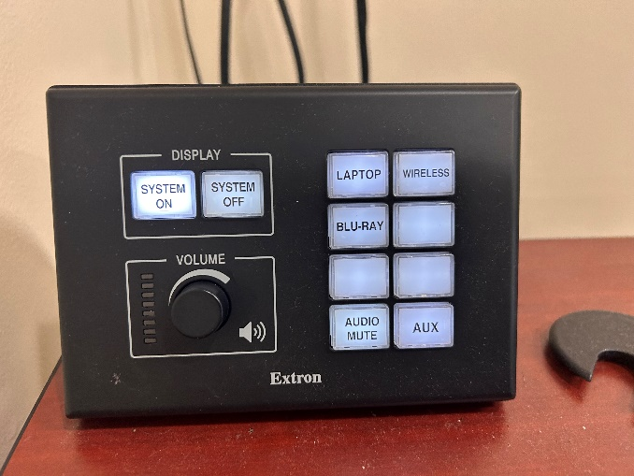
BLU-RAY Button
BLU-Ray Player

To present wirelessly you can press the Wireless Button.

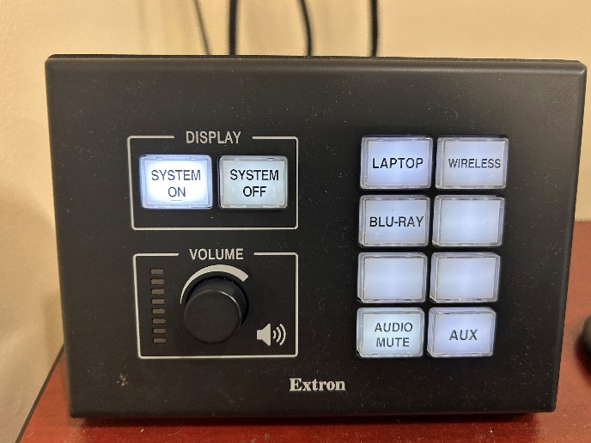
Wireless

On your windows device press “Win+K”

This will bring up a pop up menu to cast. Select the device.
If prompted enter the security code that will be displayed on the in room screens.
Select to either mirror or extend your display.

To power off the system you will click on the System Off button and close the laptop. If you were using a different laptop, reconnect the cable to the room assigned laptop on the podium.
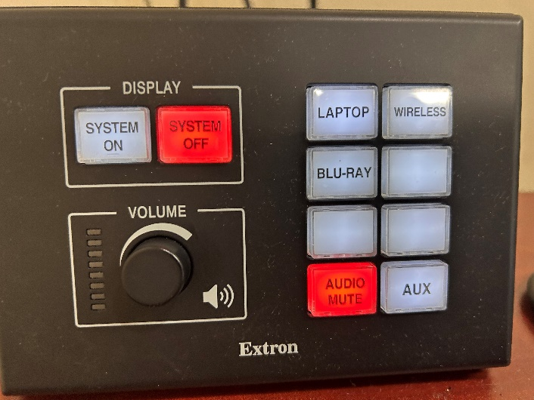
System Off button
**The Parks and Rec department can also have someone available to assist if it’s needed. You can contact Jared Steel (Park Superintendent) jared.steele@unioncountync.gov

