Agricultural Center:

Classroom 162
The Front of the room
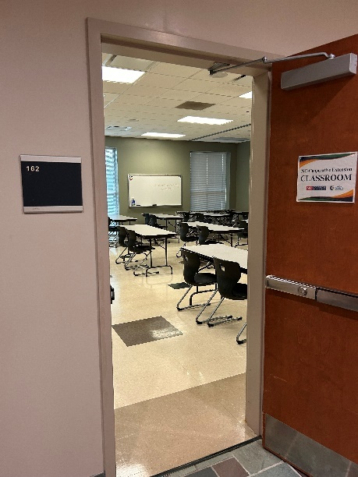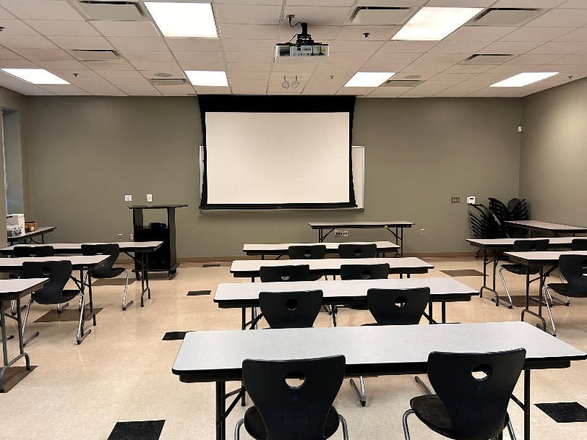

Power “On” the Control Wall Panel mounted at the front of the room; press the On button in the Display section.
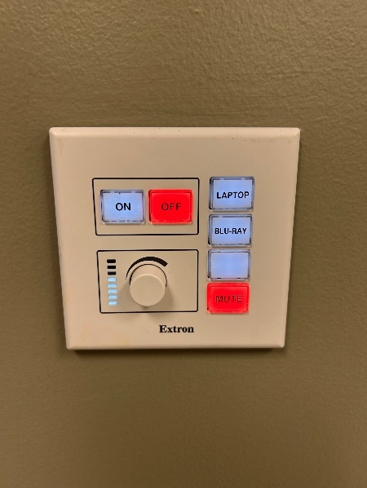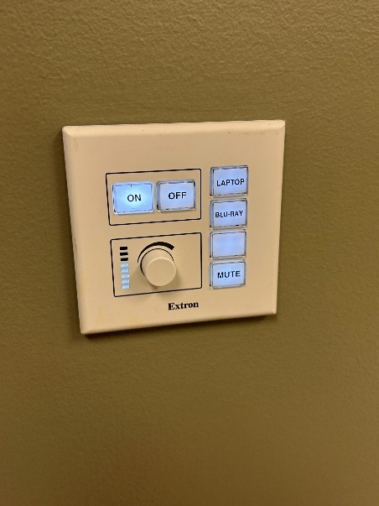
System Power
Use either the HDMI cable provided or self-provided and connect to the HDMI Input
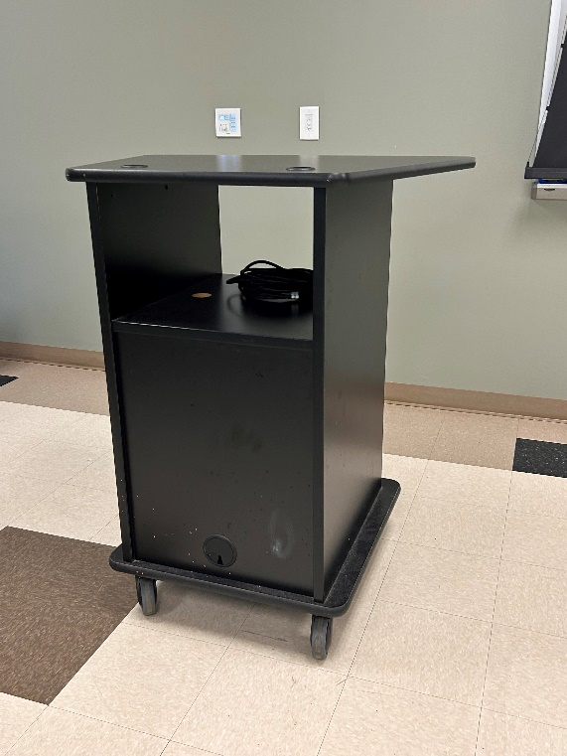
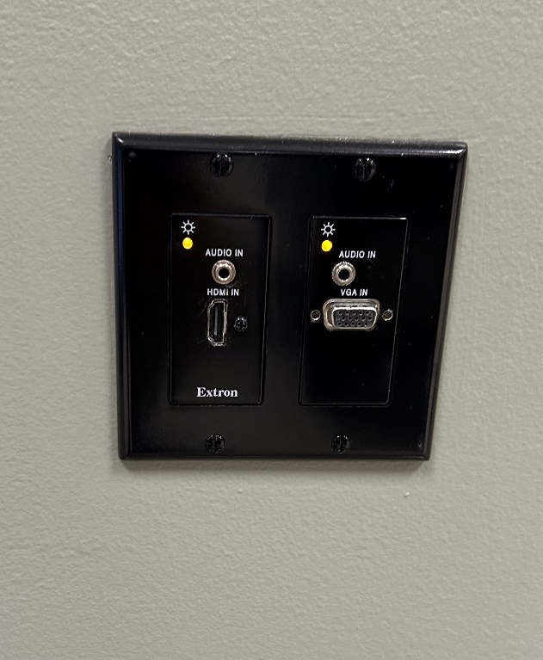

Provided HDMI Input
Wall HDMI Input

Press the “Laptop” button for the HDMI input. Turn the Audio-nob to change the volume up or down.
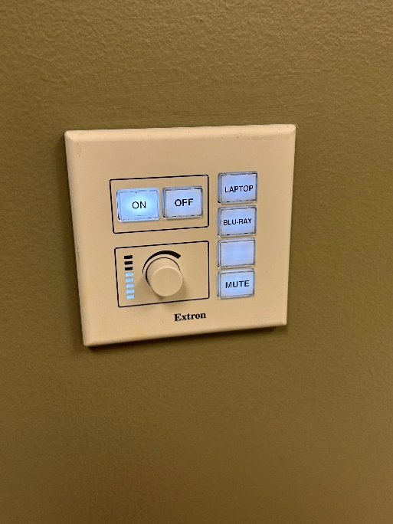
Wall HDMI Input
Mute Button
Volume Control for ceiling speakers
Room audio volume & the audio “Mute” button are also with the Control panel on the podium

There is a designated Owl Labs – Meeting Owl (360 Camera and Microphone) that can be connected to the user’s laptop, via USB cable.
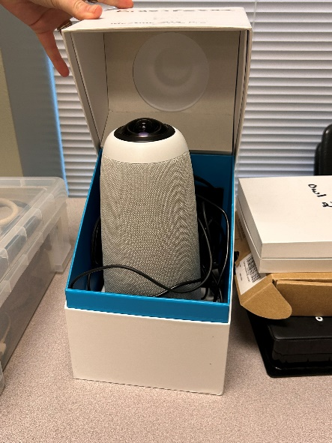

Ceiling mounted speakers are located in the front and back of the classroom.
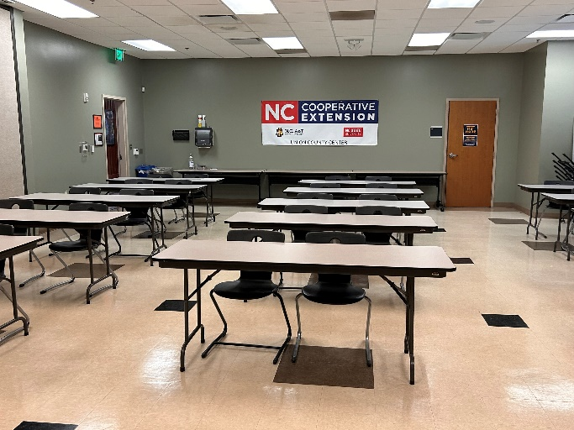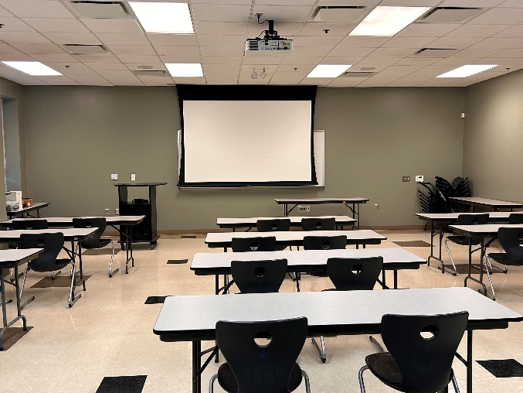
Front Ceiling Speackers
Back Ceiling Speackers
Ceiling mounted speakers are located in the front and back of the classroom.

