Agricultural Center:

Kitchen 160
The Front of the room
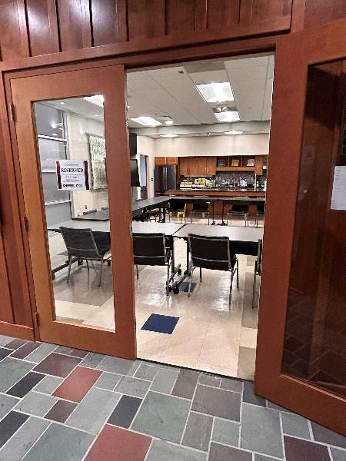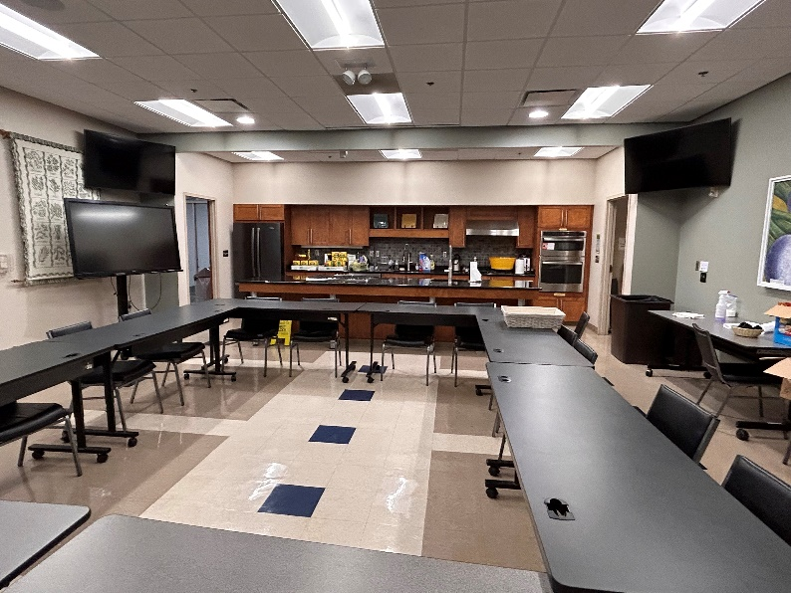

Power “On” the Control Wall Panel mounted at the front of the room; press the On button in the Display section.
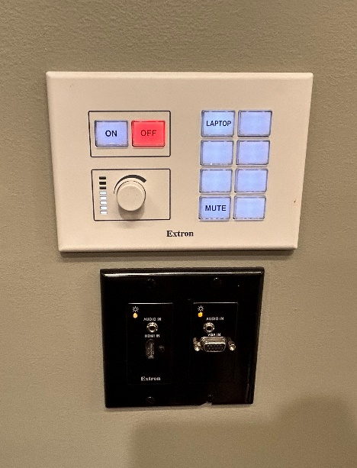
System Power
Use an HDMI cable to connect to the HDMI Input. Once the HDMI is connected to the wall input and the laptop HDMI output press the “Laptop button" button.
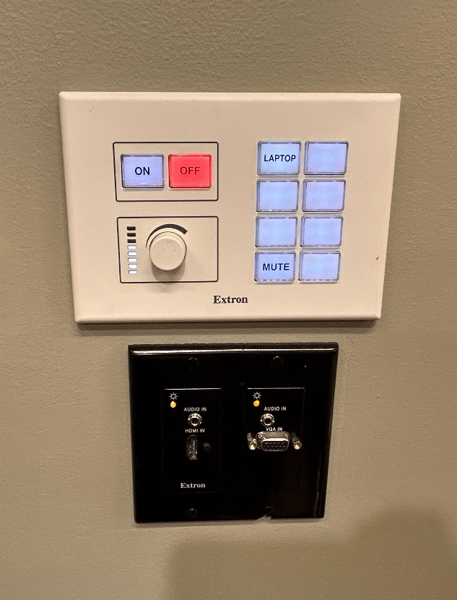

Wall HDMI Source

Wall HDMI Input

Turn the Audio-nob to change the volume up or down.
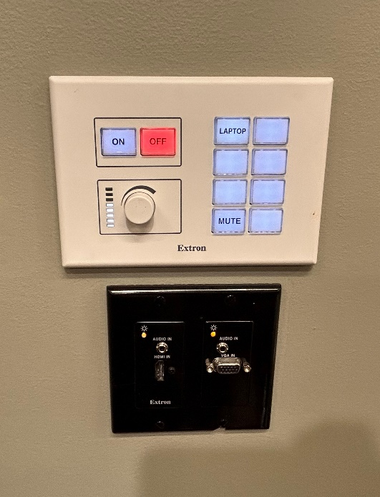
Mute Button
Volume Control
for ceiling speakers
Room audio volume & the audio “Mute” button are also with the Control panel on the podium
There is a designated ceiling mounted HD Camera to view the work being done on the stove.
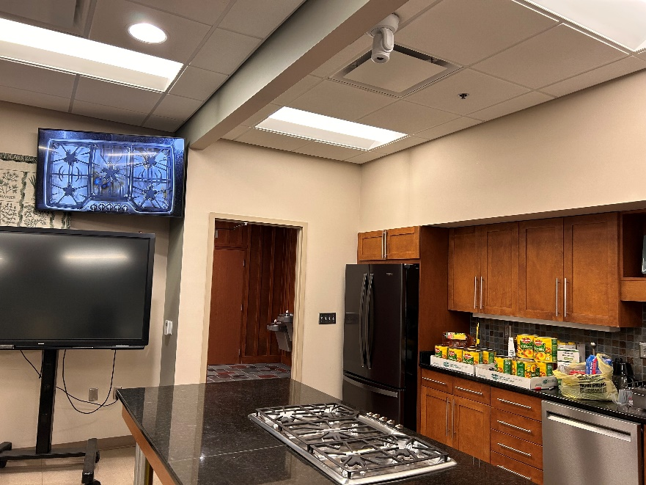
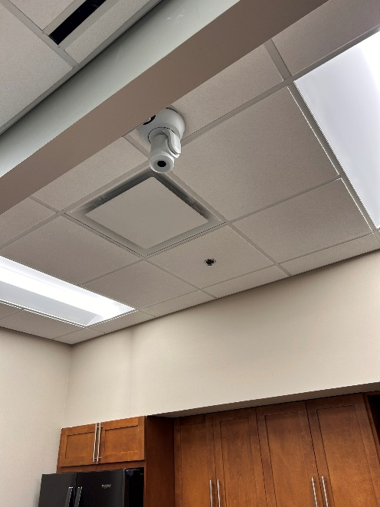

Ceiling Mounted Camera

The wall mounted button is not labeled. To access the camera view, press the blank button below the button that is labeled laptop.
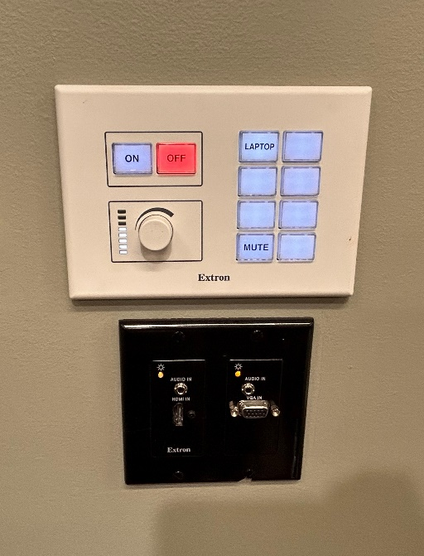
Blank
Camera Button

TV Monitors that show the presentation or stove camera.
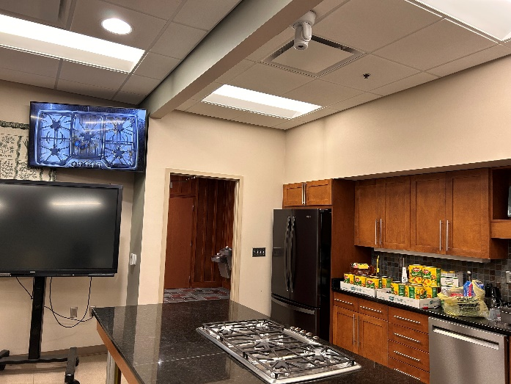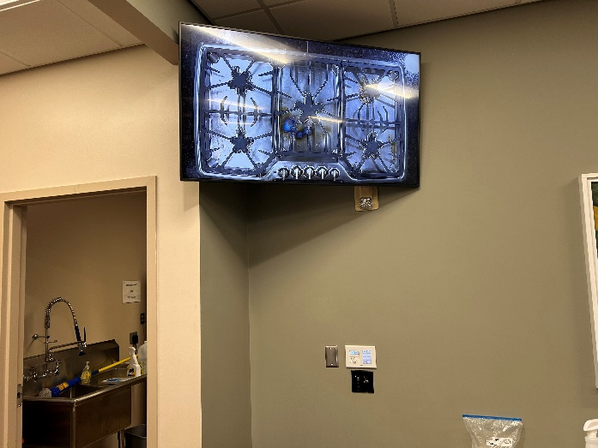
Right Front Monitor
Left Front Monitor

